**Opening web page in app :**

Create web view in xml

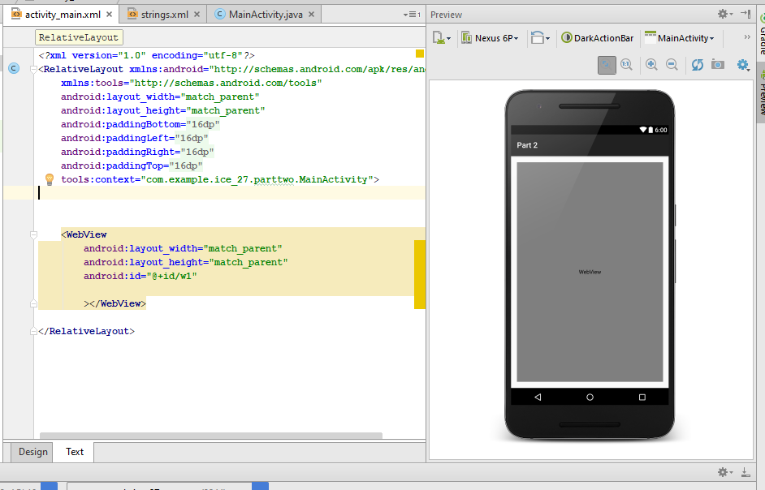

Create object and give url :

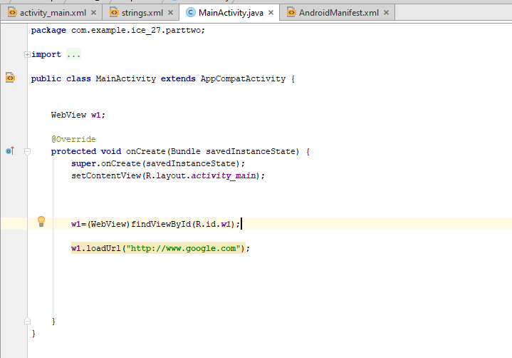

Give permission in android manifest

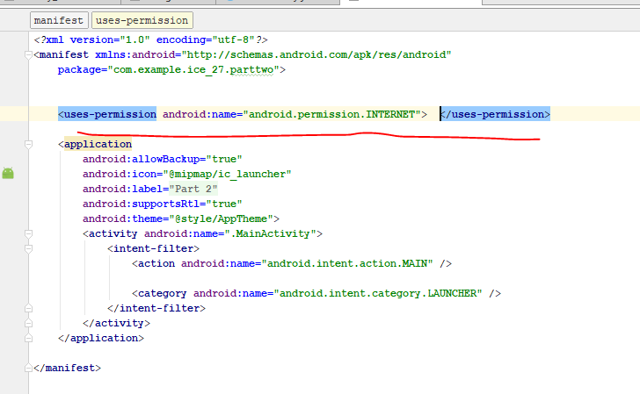

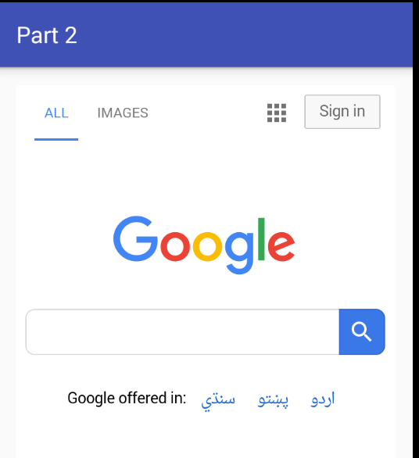

**Async Task :**

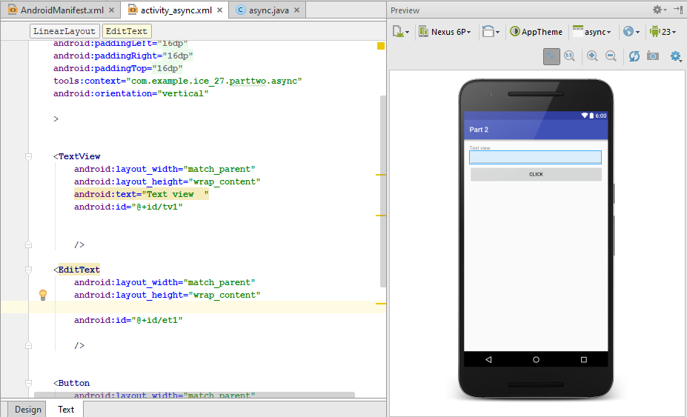

Java file :

**package** com.example.ice_27.parttwo;  
  
**import** android.app.ProgressDialog;  
**import** android.os.AsyncTask;  
**import** android.support.v7.app.AppCompatActivity;  
**import** android.os.Bundle;  
**import** android.view.View;  
**import** android.widget.Button;  
**import** android.widget.EditText;  
**import** android.widget.TextView;  
  
**public class** async **extends** AppCompatActivity {  
  
  
 EditText **et**;  
 TextView **tv**;  
 Button **b1**;  
 @Override  
 **protected void** onCreate(Bundle savedInstanceState) {  
 **super**.onCreate(savedInstanceState);  
 setContentView(R.layout.***activity_async***);  
  
 **tv**=(TextView)findViewById(R.id.***tv1***);  
  
 **et**=(EditText)findViewById(R.id.***et1***);  
  
 **b1**=(Button)findViewById(R.id.***b1***);  
  
  
 **b1**.setOnClickListener(**new** View.OnClickListener() {  
 @Override  
 **public void** onClick(View v) {  
  
  
 aexample at=**new** aexample();  
  
 String time=**et**.getText().toString();  
  
 }  
 });  
  
  
  
  
  
  
 }  
  
 **private class** aexample **extends** AsyncTask<String,String,String> {  
  
 **private** String **res**;  
 ProgressDialog **pd**;  
  
 @Override  
 **protected void** onPreExecute() {  
 **super**.onPreExecute();  
  
 **pd**=ProgressDialog.*show*(async.**this**,**"Progress Dialog"**,**"wait for "**+**et**.getText().toString()+**" Seconds"**);  
  
 }  
  
 @Override  
 **protected** String doInBackground(String... params) {  
  
 **try** {  
  
 **int** time=Integer.*valueOf*(params[0])*1000;  
  
 Thread.*sleep*(time);  
  
 **res**=**"Slept for "**+params[0]+**" seconds"**;  
  
 } **catch** (Exception e) {  
  
 e.printStackTrace();  
 }  
  
  
  
  
 **return res**;  
  
  
 }  
  
 @Override  
 **protected void** onPostExecute(String s) {  
 **super**.onPostExecute(s);  
  
 **pd**.dismiss();  
 **tv**.setText(s);  
  
 }  
 }  
  
  
}

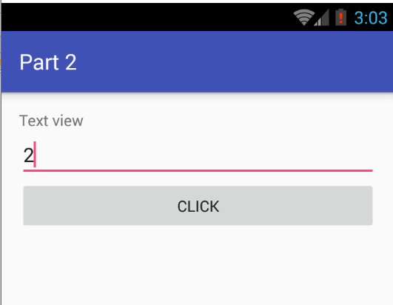

JSON :

**package** com.example.ice_27.jexample;  
  
**import** android.app.ProgressDialog;  
**import** android.support.v7.app.AppCompatActivity;  
**import** android.os.Bundle;  
**import** android.widget.TextView;  
**import** android.widget.Toast;  
  
**import** org.json.JSONArray;  
**import** org.json.JSONException;  
**import** org.json.JSONObject;  
  
**import** java.io.InputStream;  
  
**public class** MainActivity **extends** AppCompatActivity {  
TextView **t1**;  
 @Override  
 **protected void** onCreate(Bundle savedInstanceState) {  
 **super**.onCreate(savedInstanceState);  
 setContentView(R.layout.***activity_main***);  
  
 **t1**=(TextView) findViewById(R.id.***t1***);  
 **try** {  
  
 JSONObject obj = **new** JSONObject(JsonLoad());  
 JSONArray jarr = obj.getJSONArray(**"fruit"**);  
  
 **for** (**int** i = 0; i < jarr.length(); i++) {  
  
 JSONObject Jobj=jarr.getJSONObject(i);  
 String fruit=Jobj.getString(**"fruits"**);  
  
 Toast.*makeText*(getApplicationContext(),**""**+fruit,Toast.***LENGTH_SHORT***).show();  
  
 **t1**.setText(**""**+fruit);  
 }  
  
  
 } **catch** (JSONException e) {  
  
 e.printStackTrace();  
  
  
 }  
  
 }  
 **public** String JsonLoad()  
 {  
  
 String json=**null**;  
  
 **try** {  
  
 InputStream is=getApplicationContext().getAssets().open(**"example_1.json"**);  
 **int** size=is.available();  
 **byte** []buffer=**new byte**[size];  
 is.read(buffer);  
 is.close();  
 json=**new** String(buffer,**"UTF-8"**);  
  
 } **catch** (Exception e) {  
  
 e.printStackTrace();  
  
  
 }  
 **return** json;  
  
  
 }  
  
  
  
 }

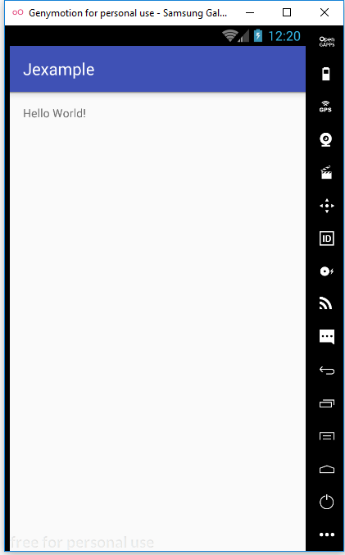

**Recycler View :**

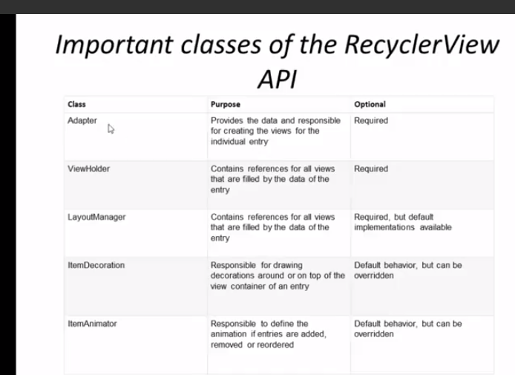

**Recycle View :**

Import from project structure .

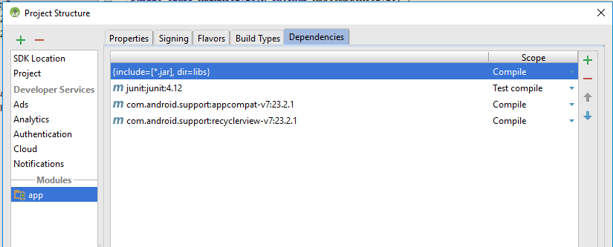

Main activity :

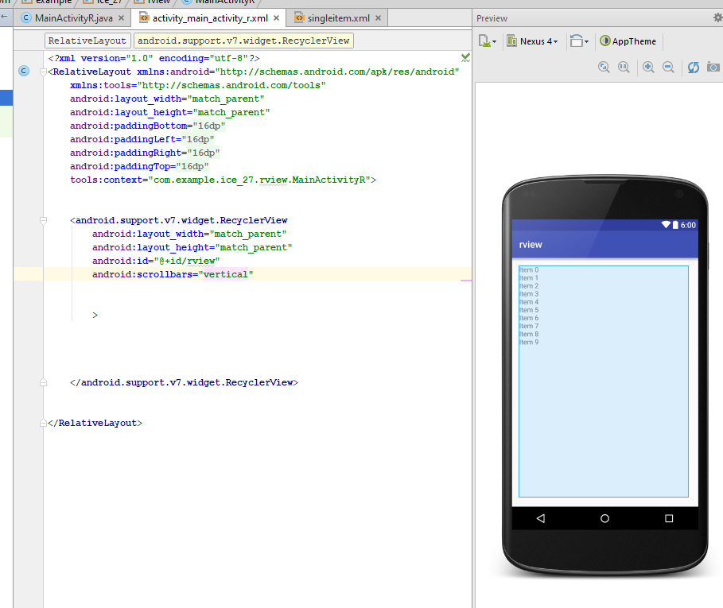

2nd single item activity :

*<?***xml version="1.0" encoding="utf-8"***?>*<**LinearLayout xmlns:android="http://schemas.android.com/apk/res/android"  
 android:orientation="vertical"  
 android:layout_width="match_parent"  
 android:layout_height="?android:attr/listPreferredItemHeight"  
 android:padding="8dp"** >  
   
  
 <**ImageView  
 android:layout_width="wrap_content"  
 android:layout_height="match_parent"  
 android:id="@+id/icon"  
 android:layout_alignParentBottom="true"  
 android:layout_alighParentTop="true"  
 android:layout_marginRight="8dp"  
 android:contentDescription="T0 DO"  
 android:src="@mipmap/ic_launcher"** />  
  
  
<**TextView  
 android:layout_width="match_parent"  
 android:layout_height="25dp"  
  
 android:id="@+id/subtext"  
  
 android:layout_alignParentBottom="true"  
 android:layout_alighParentTop="true"  
 android:layout_toRightOf="@+id/icon"  
 android:ellipsize="marquee"  
 android:maxLines="1"  
 android:text="Description"  
 android:textSize="50dp"** />  
  
 <**TextView  
 android:layout_width="match_parent"  
 android:layout_height="wrap_content"  
  
 android:id="@+id/maintext"  
 android:layout_gravity="center_vertical"  
 android:layout_above="@id/subtext"  
 android:layout_alighParentTop="true"  
 android:layout_toRightOf="@+id/icon"  
 android:ellipsize="marquee"  
 android:maxLines="1"  
 android:text="Description"  
 android:textSize="50dp"** />  
  
  
  
  
  
  
  
  
  
</**LinearLayout**>

Main Class :

**package** com.example.ice_27.rview;  
  
**import** android.support.v7.app.AppCompatActivity;  
**import** android.os.Bundle;  
**import** android.support.v7.widget.LinearLayoutManager;  
**import** android.support.v7.widget.RecyclerView;  
  
**public class** MainActivityR **extends** AppCompatActivity {  
  
  
 RecyclerView **rv**;  
 RecyclerView.LayoutManager **LayoutManager**;  
 RecyclerView.Adapter **rAdapter**;  
  
  
 @Override  
 **protected void** onCreate(Bundle savedInstanceState) {  
 **super**.onCreate(savedInstanceState);  
 setContentView(R.layout.***activity_main_activity_r***);  
  
  
  
  
 **rv**=(RecyclerView) findViewById(R.id.***rview***);  
  
 **rv**.setHasFixedSize(**true**);  
  
 **LayoutManager** = **new** LinearLayoutManager(**this**);  
  
 **rv**.setLayoutManager(**LayoutManager**);  
  
  
 String arr[]= {**"abc"**,**"xyz"**,**"wbc"**,**"7mb"**};  
  
 **rAdapter**=**new** Myadapter(arr);  
  
  
 **rv**.setAdapter(**rAdapter**);  
  
  
 }  
}